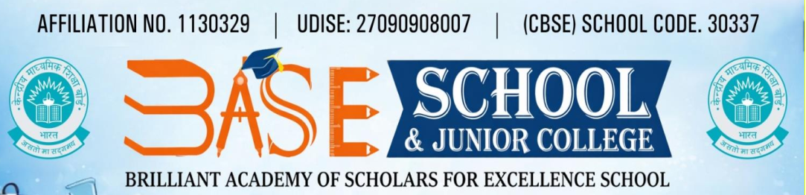
Vidya Nagar, Koradi Road, NAGPUR – 441111
CBSE Affiliation No: 1130329 UDISE : 27090908007 Email:baseschoolngp@gmail.com

Parents- Teachers Association- 2026-2027
1.Executive Committee
1 | President | Prof. Gaurav Mahule | Principal
2 | Vice President | Mr Rakesh Mishra | Parent
3 | Secretary | Mrs Arti Bangade | Parent
4 | Jt Secretary | AV Mohandaas | Admin Officer

2. Members- Parents |  |  |  | 3. Members- Teachers
S.No | Grade |  |  | S.No | Grade
5 | I | Mrs Bhagyashree Dambhare |  | 15 | I | Ms Ayushi Pandey
6 | II | Ms Neha Fulbhande |  | 16 | II | Ms Yasmin Shiekh
7 | III | Mrs Dipti Goswami |  | 17 | III | Ms Pranita Paidalwar
8 | IV | Mr. Suraj Thakre |  | 18 | IV | Ms Sejal Tiwari
9 | V | Mr Sudhir Bhangde |  | 19 | V | Ms Sneha Meshram
10 | VI | Mr. Mahesh Chambhare |  | 20 | VI | Mr Nehal Bagde
11 | VII | Ms Ruhina Khan |  | 21 | VII | Ms Krishnaveni S.
12 | VIII | Mr. Rakesh Mishra |  | 22 | VIII | Ms Delphina Norbert
13 | IX | Ms. Sujata Shende |  | 23 | IX | Mr Sonali Viaragade
14 | X | Mr Gajanan Nishitkar |  | 24 | X | Mr Pranali Gawande

